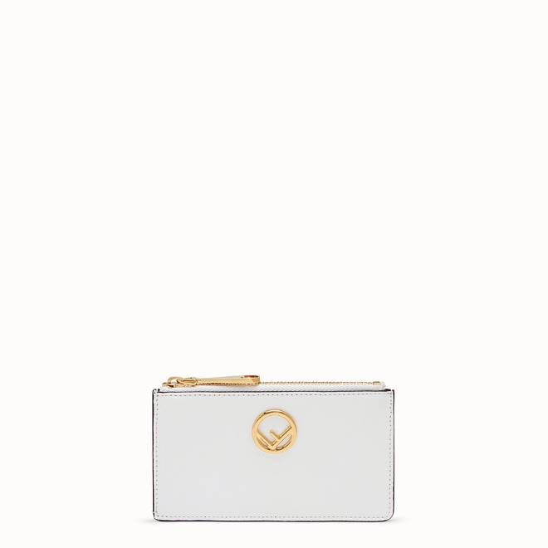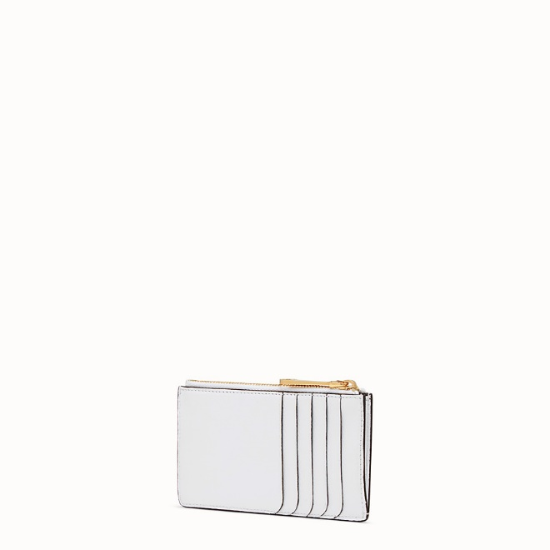

FENDI-CARD POUCH

$420.00

COLOR :White leather card holder  
SIZE : ONE SIZE  
IN STOCK

[Detail](http://127.0.0.1:60314/content/K6_bJV98pR7RBEfQAAAe/t5r1gsi/lOi2z1L/ZwpfDtn/JTIGzco#collapse)

Small slim F is Fendi pouch with gusseted interior and 5 card slots on the back. Zip fastening. Made of white cruise leather. Decorated with the new Fendi logo. Gold metalware.Made in Italy.

• Length:13,5

• Height:8

• Depth:,5

• Composition:100% calf leather

Universal Style: Product Code:8M0348A18BF11CB

More information? [Click here](http://127.0.0.1:60314/content/K6_bJV98pR7RBEfQAAAe/t5r1gsi/lOi2z1L/ZwpfDtn/Information/FENDI-BIFOLDA.docx)

[CARE & COMPOSITION](http://127.0.0.1:60314/content/K6_bJV98pR7RBEfQAAAe/t5r1gsi/lOi2z1L/ZwpfDtn/JTIGzco#collapse1)

• Leather

• Imported